November 16, 2018
Pervasive chat support – Case Study Technology Experience Support
Case Study
Contents
1 About EY 2
2 Purpose 2
3 Background 2
4 Problem Statement 3
5 Environment 3
5.1 Organization 3
5.2 Regions and Countries 3
5.3 Decision Making 4
6 Current Support Model 4
6.1 Support Model 4
6.2 Volumetric Information 5
7 Objectives 5
8 Key Asks as a response to the case study 6
8.1 High level approach to meet objectives / Design Principles 6
8.2 Identifying Target Audience Needs 6
8.3 Technology fit and Market presence 6
8.4 High level implementation framework 6
8.5 High Level Project Plan and technology roadmap 6
8.6 Change Management Plan 6
8.7 Country Onboarding Plan 6
8.8 Pricing Approach 6
8.9 Critical Success factors and Key Issues / Risks 6
8.10 Recommendations 6

List of Figures
Figure 1: Current Support Model 4
Figure 2: Overall Ticket Volumes 5
Figure 3: Ticket volumes by contact type 5

About EY
EY is a global leader in assurance, tax, transaction and advisory services. The insights and quality services we deliver help build trust and confidence in the capital markets and in economies the world over. We develop outstanding leaders who team to deliver on our promises to all of our stakeholders. In so doing, we play a critical role in building a better working world for our people, for our clients and for our communities.
EY refers to the global organization and may refer to one or more, of the member firms of Ernst & Young Global Limited, each of which is a separate legal entity. Ernst & Young Global Limited, a UK company limited by guarantee, does not provide services to clients.
For more information, please visit www.ey.com.

Purpose
The purpose of this document is to outline a real life case study for the global implementation of chat as a primary channel for providing technical customer support for the employees of EY. The analysis of the case study and recommendations will be used to select a Senior Product Manager with extensive knowledge of Consumerized experience creation to lead the implementation of Pervasive Chat Support within EY.

Background
Technology Experience Support (TES) is the customer facing arm of EY Technology working with the primary goal of ensuring our customers - EY employees are successful in their day to day business by supporting all their technology needs. EY Technology and TES is on a journey of continuously transforming the end user experience by adopting cutting edge technologies for enabling high quality, modern, intuitive, pervasive channels of customer support.
EY has a mature technical support environment. Less than 5 years ago, EY embarked on a transformational journey to revamp the support ecosystem across all the global member firms. From an in house, region/country specific service desk, EY outsourced the 1st level of technical support to a vendor that implemented a Global Service Desk (GSD). Most of EY member firms now use the Global service desk as the first contact point for all technical support requirements. Some member firms are yet to be on boarded on the GSD mostly owing to the economics of the solution. Currently, the majority of incidents are logged through voice calls. A small portion is logged through chat. Along with GSD implementation the vendor also transformed the support ecosystem – key projects included - providing access to support from mobile phones (Mobilina), remote solving capability (Bomgar) and Analytics and automation based on the Vendors proprietary AI platform. EY uses Service Now to track all the service requests and also for operations management.
EY is on the cusp of transforming their desktop engineering and onsite support environment using cutting edge technologies in order to be at the forefront of technology enabled customer support. EY has the vision to provide technical support that is Zero Touch, Intuitive Native to Millennials with a Consumerized Experience.
The average age of EY employees is less than 27 years and every year more digital natives are making their way to the firm. It is our vision to continue to enhance customer experience, particularly for our digital native and millennials and to drive natural shift left behaviors – we need to create a ubiquitous channel that is effective, efficient and pervasive

Problem Statement
Shift left and standard, remote and service desk model is not adopted as much as we would like both from an end user perspective in some geographies and from a stakeholder perspective in other geographies due to economics. We need a well adopted service model to continue our intentions of transformation for our customers which if founded on adoption of such support models and reduce reliance on traditional, high touch and shoulder tap service models which tend to burden the transformation process. We need to be able to do this natural and aligned to customer expectations both from a user experience and economics perspective.
Chat with the right design principles built in might be one of the most effective answers to this problem statement. This along with exploiting the innate efficiencies within the chat operate model along with some allocation benefits to countries we could create a blend of experience and economics that will drive the desired adoption.

Environment

Organization
TES is a globally wide spread organization providing front line technical support services to the EY end users / employees. TES works with a vendor to provide Global Service Desk (GSD) services to the end users. The GSD program is led by the Remote Services and Early Life Support (ELS) delivery leader. Apart from GSD, TES has an onsite support team that is primarily staffed in house. The onsite services team is spread across 4 Areas (Americas, Europe, MEIA and APJ). TES also provides a shared services via the Customer Enablement Services team. Customer Business Liaison is group within TES that manages the TES Stakeholder relations with Area managers and Business Leaders.
Level 1 Customer support services are provided by the GSD team (vendor), managed by Remote Services Lead. Majority of the support services are provided over voice, with little volumes supported on the chat platform.
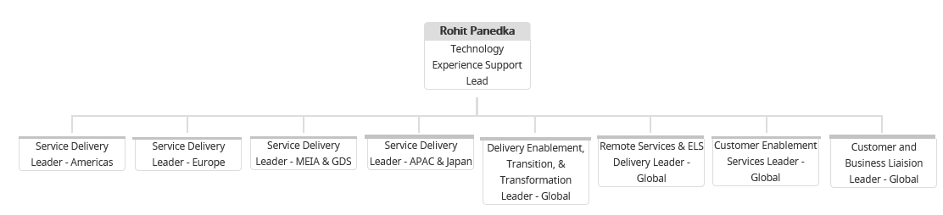

Regions and Countries
EY has over 265,000 end users spread over 130 countries, speaking over 30 languages. The countries are spread across 4 main Areas – Americas, Europe, MEIA and Asia Pacific. List of regions and countries is attached. This will give a good idea about the concentration of the end user population in few large countries, and at the same time the diversity of economics of the countries were the end user population is spread.

Decision Making
The decisions regarding implementing new support solutions or changing existing ones is taken by the Global Technology Experience Support leadership. However, individual member firms (countries / regions) may choose to opt out of certain technology changes and continue to operate individually in case a solution is not suitable or economically viable. Having said that, there is a push from Global Leadership to adopt common standards across all geographies, so special focus needs to be placed on solutions that are aligned to different economies. Each member firm is approached, with the help of Area Relationship Managers (ARM) and needs to be on boarded / bought into any new support solution seeking the approvals of local partners and IT leaders before implementing in that geography.
Expected result for pervasive chat project
While, the above elicited country on boarding process is true for most large global implementations, the expectations for the pervasive chat journey are slightly different. We expect that the chat functionality is so intuitive and user friendly, that it becomes a natural choice for end users to utilize it as their primary support medium. The solution should sell itself, be ubiquitous and at the same time economically viable, such that all member firms want to automatically opt for it.

Current Support Model

Support Model
Given below is a simplistic view of the support operate model today. End users can contact the level 1 global service desk either via calls, mails, chat. Sometimes, end users also walk up to their local onsite support engineers, however, as a practice they are urged to reach out to the level 1 support first.
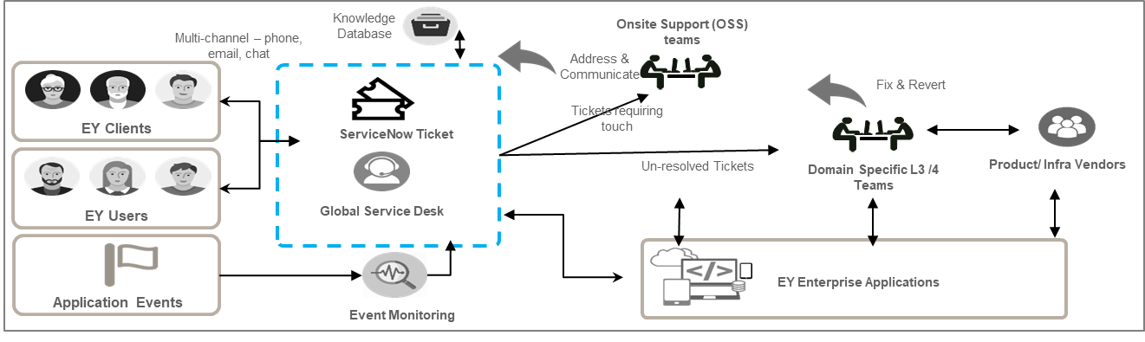
GSD agents may resolve the ticket based on knowledge data base or allocate the ticket to the rightful owners including the onsite support teams or the level 2/3 teams as required. End users or sometimes GSD agents log tickets using Service Now (Snow). The whole ticket lifecycle is managed using service now.
Figure 1: Current Support Model
Today, majority of ticket volumes are handled via voice support. EY aims to reverse this dynamic and entice the user to use chat over voice. This could be by putting the “chat for help” option everywhere the user could look. Basically get the user to notice a chat option before they even start to think about calling a phone number. In future, an intelligent, conversational chat system could be the entry point into the support ecosystem, auto solving some of the known issues, while redirecting to the manned service desk for resolving more complex issues.

Volumetric Information
Given below is the high level volumetric information. The idea here is not to provide exact data, but to give a general idea of the support requirements of EY.
Given below are the area wise ticket volumes for the year 2018, up till Nov 20th
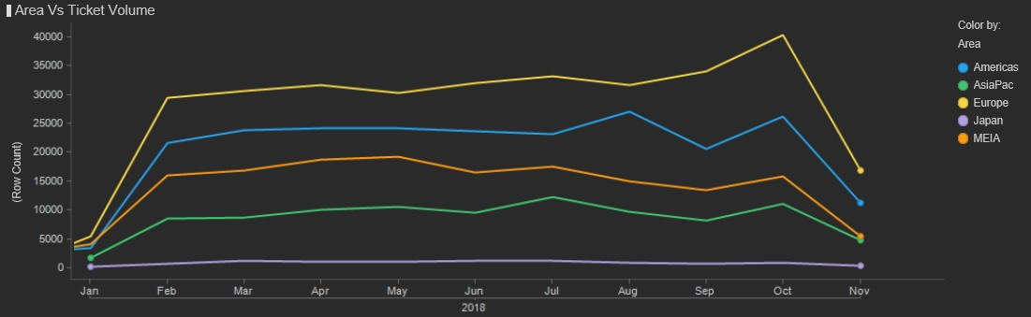
Figure 2: Overall Ticket Volumes
Given below are the last 12 months ticket volumes by contact type. It is evident from below figure that voice support significantly dominates the chat support.
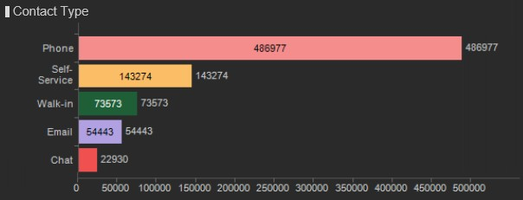
Figure 3: Ticket volumes by contact type
The reader can make reasonable assumptions regarding the data, while answering to the case study. No further information would be provided.

Objectives
- To enhance customer experience and particularly for our digital native and millennials and to drive natural shift left behaviors we need to create a ubiquitous channel that is effective, efficient and pervasive
- Ability to drive a very discoverable and accessible service channel that can be ubiquitous, mobile and point of exact need
- Maximize the ticket volumes supported via the chat platform. Currently, most of the support volumes are dominated by voice. We would like to reverse this dynamic.
- Maximize the efficiencies that come with such a channel, operate and economic model
- The capability itself becomes a critical building block for support transformation and support services of the future
- The technologies stacks needed could also be building blocks and leverageable for future builds
- Less technology and infrastructure drag compared to other channels while does not lose the benefits of real time queue based operate models (like email or self-serve submissions)
- Feedback friendly

Key Asks as a response to the case study
Respond with a presentation of not more than 10 slides with the following.

High level approach to meet objectives / Design Principles
Overall approach to meet EY objectives, timelines.

Identifying Target Audience Needs
How do we validate the above understanding of problem statement and user expectations?
Based on your experience what end user needs will we be addressing? Identify use cases and solutions.

Technology fit and Market presence
What are the products and capabilities that we need or can leverage?

High level implementation framework
How do the new products / technology integrate with the existing EY technology ecosystem?

High Level Project Plan and technology roadmap
- Timelines, Pre-requisites, country onboarding sequence, critical milestones
- Solution lifecycle – How will the solution evolve (plain vanilla chat to AI based conversational chat etc.) in a way that it naturally becomes the platform of choice for all end user support requirements?

Change Management Plan
EY aims at moving more than 50% of the support volumes to the chat platform. This will also involve a big change in the way the employees envision the support today and their behavior / method of seeking out technical support. How will we ensure maximum participation on the chat platform (1) marketing, motivating / training employees (2) through intuitive design and innovative point of need placement?

Country Onboarding Plan
How can we ensure the countries adopt this solution? How can we design a solution in a way that is inclusive of country expectations and at the same time globally consistent?

Pricing Approach
What will the approach be to price the solution in a way that it aligns to usage of the service and also in a way that it is affordable to all the countries?

Critical Success factors and Key Issues / Risks
- What are the pre-requisites for success? How do we measure success?
- Key risks and mitigation plans.

Recommendations
- What are the user experience and design principles that need further exploration?
- Any other recommendations.

